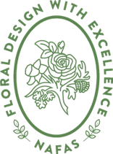
NAFAS Flower Arranging
Part 1
Students Evaluation Document
The National Association of Flower Arrangement Societies
Registered Charity 1101348

Design number_________________________________
Name | Yes | No
Are the mechanics secure?

Are the mechanics well hidden? If appropriate to the design

Are the materials conditioned?

Does the design have clear outlines and shape?

Does the design have appropriate dominance/focal impact?

Does your design have recession? If appropriate

Have appropriate colour or colours been used?

Are the materials in scale with each other?

Have the materials been used to create rhythm?

Does the design have appropriate visual and actual balance?

Are there diverse contrasts in form and texture?

Are all the materials in harmony with each other?

Is there sufficient space within the design? If appropriate

Is the design in proportion?

Is there a distinctive line? or contrast in line within the design?

Is the design fit for the intended purpose?

Tutors signature

