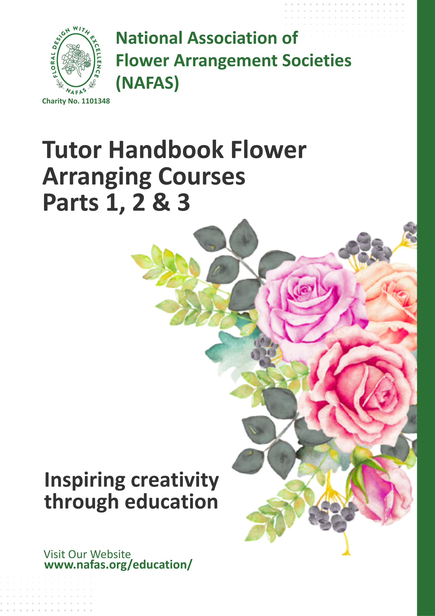

“As tutors we are aware we need a little something extra in our repertoire e.g. knowledge or technique for the most natural or experienced students. We enable some students to develop their ideas and understanding. In contrast, for the students with less flair, we simplify a design to enable them to complete their design. The most important thing is students are getting a positive experience and taking home their design they created and can be proud of, especially in Part 1. The student will take home the critique and advice given by their tutor to improve next time’
Julie Pearson

Length of Courses
NAFAS Flower Arranging Part 1-18 hours contact over 6 weeks
NAFAS Flower Arranging Part 2-30 hours contact over 10 weeks
NAFAS Flower Arranging Part 3-60 hours contact over 20 weeks

Qualifications to Teach the Course
All NAFAS National Teachers qualify to teach the courses. To become a NAFAS National Teacher the following qualifications are required:
Level 3 or above Certificate in Teaching
Level 3 or above Certificate in Flower Arranging/Floral Design or Level 4 Certificate in Floristry
Tutors should prepare and submit a Risk Assessment for their venue, and this should in turn be discussed with their students. Tutors should provide evidence of suitable insurance cover to the Moderator. Tutors should be aware of GDPR (General Data Protection Regulation).

Overall course management lies with NAFAS. Once the National Tutor has registered, the Course Consultant will appoint an area moderator to support and advise the Tutor.

Help and Advice
This can be obtained from the Education Administrator for Administration issues and Course Consultant for course issues. Both will offer guidance and support where needed.
Course Consultant: courseconsultant@nafas.org.uk or education@nafas.org.uk

NAFAS National Tutor Fees
NAFAS National Tutor Membership: £50 annually if teaching NAFAS courses. (Tutor to complete registration online). This an annual payment and covers any number of courses being taught during that period of twelve months.
Tutors must have current £5million public liability insurance cover.
The tutor can choose how, when and within a timescale to suit, to deliver any of the NAFAS flower arranging courses.
National tutors wishing to teach any course must send the Class Registration Form to NAFAS headquarters to enable NAFAS HQ to receive payment and promote the course on the website.
Costs for classes around the country may vary considerably, the tutor is responsible and should work out the cost for their courses, very carefully to include: -Tutor NAFAS membership fee, tutor tuition fees, venue hire, Public Liability Insurance, plant materials cost, sundries and travel costs, refreshments, etc. The student NAFAS membership fee of £10 is payable to NAFAS directly when the student registers and is not included in the costing for the course. However, the cost of accreditation and administration should also be incorporated into the tutor course fees, please see below for the correct fee to correspond with the course being taught.

NAFAS Student Membership – this is applied for online
Students pay a Student Membership Fee of £10, to NAFAS which is an annual payment and any number of courses can be taken within this time. (Student to complete registration online)
The money is transferred by BACS payment to NAFAS when the student registers online.
The Student Membership gives access to the NAFAS student resource page on the NAFAS website. This is an added membership to club fees or direct member fees without exception.

Additional Charges to Students by NAFAS
This course covers accreditation and administration and is incorporated in to the charge to the student by the tutor.
Flower Arranging Part 1 £20.00 per student
Flower Arranging Part 2 £40.00 per student
Flower Arranging Part 3 £60.00 per student
Please note: this charge is in addition to the Student Membership Fee of £10.00.
These fees are factored into the costings worked out by the tutor for students to pay for the course. The tutor collects the total cost of the course from the students and then transfers the student charges to NAFAS as shown above at the same time as registering the class

Venues
The minimum resources necessary to deliver these courses will include:
- Toilets and good access
- Tables and chairs with clear surfaces
- Water available
- Premises in accordance with Health & Safety (H & S) requirements

Tutors Role
Know and understand the following NAFAS policies. It is the tutor’s responsibility to discuss with students:
GDPR – The tutor should ensure that they have a signed coy of the following statement assuring the student of complete confidentiality of their contact details before the course commences.
Class Register – the tutor should have this at each class in case of emergency
Safeguarding
Equality, Diversity and Inclusion
Disabilities Guidelines
Health and Safety
- Discuss Health and safety issues which are appropriate. Retain a copy of the risk assessment signed by the students.
- Be aware of Equal Opportunities as said in the NAFAS Equality, Diversity and Inclusion Policy on the NAFAS website and pass information on to students. Tutor to retain signatures from students to demonstrate they have understood the current legislation.
- Explain to the students how to complete their Student Diary of Work, Student Evaluation & Student Tracking. (Forms provided in Student Diary of Work booklet which is sent to the tutor.)
- Use the Scheme of Work provided for each lesson & course.
- Deliver the course offering appropriate learning opportunities with tutorial support and suggest reference materials for each course.
- All practical designs should be demonstrated by the course tutor either at the class or the class before the student is requested to complete one.
- Carry out weekly critique on each student practical designs and written feedback.
- Provide clear and constructive feedback 1to1 and as a group critique to all students on a weekly basis (record feedback on student diary of work)
- Participate with the course moderators as appropriate.
- Provide clear and comprehensive records of teaching / learning process. (Forms provided by NAFAS) Including: Tutor Tracking, Class register as means of referral in case of an emergency and check student attendance.

NAFAS Publications
- The National Teachers Committee recommends the NAFAS publications as a resource for both the Tutors and the Student. Please note that there is 20% reduction on the cost of a minimum of 5 publications bought online from NAFAS.

Students requesting added support to complete their course (Equality, Diversity and Inclusion)
NAFAS education must make reasonable adjustments within our teaching to help students complete the course if required. Each student circumstance must be considered and help offered. This request is on the Class Enrolment Form given to the student by the tutor at the first class
Moderation
To maintain and ensure a high standard of teaching and learning NAFAS will only issue certificates for courses if one/two moderations are carried out for each course, Part 1, Part 2 or Part 3.
Moderation will be completed during the course and at the end of the course.
The Course Consultant will give information at the time of course running
Tutors will receive a copy of the moderator's report.
Certification
Certificates provided by NAFAS headquarters. All certificates of completion will be sent to the tutor.
Students completing all outcomes will achieve certificates. A minimum of 75% attendance in class is needed for certification.
Student Dairy of Work
This consists of:-
- Student Enrolment Form (to be completed by Student and hand4ed to Tutor who keeps them for the duration of the course)
- Student Subject Unit Outline
- Student Diary of Work page
- Evaluation
- Student tracker
Each floral design practical should have a corresponding evidence sheet within their diary of work which includes tutor feedback.
Each piece of work should be signed by the students to authenticate their work. Photographic evidence is required within the diary of work.
This can be presented in a digital format by the student. If the student is presenting their work digitally then the feedback from the tutor should be given during the lesson on a small receipt type booklet, which has a duplicate page. The student receives the top copy to either scan or attach to their work.

Health and Safety
Tutors and students have a legal duty to take reasonable care for the health and safety of themselves and of other people who may be affected by what they do or fail to do. This duty implies taking positive steps to understand the hazards in the workplace, to comply with safety rules and procedures and to ensure that nothing they do, or fail to do, put themselves or others at risk. It is the responsibility of all tutors and students to report any shortcomings in health, safety and welfare arrangements, any accident, cause of ill health, dangerous occurrence and any incident which may have implications for the health, safety, and welfare of others, to the appropriate body as stated in the NAFAS Health and Safety policy. Tutors must comply with the Health and Safety Policies and any other relevant procedures and policies of the premises they are using.
Risk Assessment and Checks
Tutors must carry out their own Risk Assessment to raise awareness of potential risks and hazards. Students sign and date this on induction. Risk Assessments should be carried out and continuously reviewed. The findings of the individual Risk Assessment should be recorded and kept in the tutor file.
Accidents or Incidents
Tutors must ensure that the appropriate insurance cover is in place. Any accident or incident must be recorded in an accident/incident book or form. We recommend that the Tutors have their own Accident/Incident Book or forms. Any serious accident or incident must be reported to the Education Administrator at NAFAS Head Office as soon as is practicably possible.
Fire Procedures
All tutors and students should familiarize themselves with the procedures applicable to their premises. Fire and evacuation procedures must be displayed prominently in the building. Regular testing of fire alarms and evacuation procedures should take place.
First Aid
All premises must be equipped with a First Aid box suitable for that location and a notice displayed of the location of a First Aid Officer or contact details of the nearest medical assistance. Check that the First Aid box is fit for purpose and in date.
Duty to Report
Major injury or death must be reported to the Health and Safety Enforcing Authority The reporting procedures given in the Health and Safety Executive pamphlet ‘Reporting of Injuries, Diseases and Dangerous Occurrences Regulations (RIDDOR 2013)’ must be followed. A copy can be downloaded from: www.hse.gov.uk/pubns/indg453.htm
Complaints against the NAFAS organisation
Be aware of the NAFAS Complaints Procedure
Tutor should always first discuss problems or issues with the Course Consultant.
Students should always discuss first their problems or issues with their tutor. If a resolution is not reached with the course tutor, the students should inform the Course Consultant by email: courseconsultant@nafas.org.uk
Copyright Agreement
Tutor should provide students with confirmation that the course content is bound by copyright laws within the UK and the distribution of the course content outside of the course is strictly prohibited.
Documents for NAFAS Flower Arranging Parts 1, 2 and 3
TUTOR HANDBOOK
Available online
NAFAS TUTOR MEMBERSHIP FORM  Available online  This has to be completed and the annual charge by NAFAS transferred, before the course can be taught. During the twelve-month period any number of the NAFAS courses can be taught. | NAFAS STUDENT MEMBERSHIP FORM  Available online  Each student has to complete this online before they can commence the course
CLASS REGISTRATION FORM
This has to be completed and sent to NAFAS with the student fees as listed below being transferred to NAFAS before a class can commence

Course fees are calculated by the tutor for the student, to include the charges by NAFAS to the student - £20 for Part 1, £40 for Part 2 and £60 for Part 3 per student
The tutor collects in the course fees and transfers to NAFAS the charge per student as stated above.
STUDENT LEARNING OBJECTIVES  This is the course Scheme of Work and Lesson Plan for each of the courses. | STUDENT DIARY OF WORK  This composes of Student Enrolment Form, Student Subject Unit Outline, Student Diary of work page, Evaluation Form and Student Tracker.
TUTOR TRACKING
This is to track completion and marking of students practical
RISK ASSESSMENT
Tutor to compose according to venue and class activities. There is a copy on the website.
CLASS REGISTER
This is to be used in an emergency to check the attendance of the students

DOCUMENTS FOR THE COURSE AVAILABLE ON NAFAS WEBSITE www.nafas.org,.uk

General documents
Tutor Handbook
Tutor NAFAS Membership Registration
Student NAFAS Membership Registration
Class Registration

Documents for Flower Arranging Part 1
Student Learning Objectives
Student Subject Unit Outline
Student Diary to contain the following:
- Student Enrolment Form
- Student Diary of Work first page
- Student Evaluation
- Student Tracking
Tutor Tracking

Documents for Flower Arranging Part 2
Student Learning Objectives
Student Subject Unit Outline
Student Diary of Work to contain the following:
- Student Enrolment Form
- Student Diary of Work first page
- Student Evaluation
- Student Tracking
Tutor Tracking

Documents for Flower Arranging Part 3

Student Learning Objectives
Student Subject Unit Outline
Student Diary or Work to contain the following:
- Student Enrolment Form
- Student Diary of Work first page
- Student Evaluation
- Student Tracking
Tutor Tracking

NAFAS FLOWER ARRANGING PART 1
Recommended 6 x 3-hour classes - total of 180-hour class time. Written work which takes the form of completing a Student Diary of Work which records all practical work done at each class. These forms are provided.
Class 1
Student understanding of how course is run and completing their diaries of work, evaluation forms and tracking form.
Health and Safety within the Classroom. Begin to identify and condition plant materials. Begin to evaluate work. Understand how to put together a bunch of flowers and place in water in a jam jar.

Class 2
Conditioning and identifying plant material. Basic tools and equipment used for flower arranging. Advantages and disadvantages of using floral foam and alternative mechanics.
Complete a line design using a pin holder. Learn how to arrange an all- round circular design using wire mesh to support stems in water

Class 3
Conditioning and identifying plant material. Begin to understand flower arranging terminology. Evaluating designs. Health and Safety in the Classroom. Complete an all -round circular design using wire mesh to support the stems in water. Learn how to assemble a symmetrical triangle design using floral foam

Class 4
Introduction to Elements of Design. Complete a symmetrical triangle design using floral foam. Learn how to arrange a Pave design

Class 5
Introduction to Principles of Design. Complete a pave design. Learn how to assemble a parallel design
Class 6
Completing the course and recap on course. Complete a parallel design.

Recommended Publications to go with the course.
These are all NAFAS Publications which are available on the NAFAS website https://www.nafas,org.uk/pc/handbooks/
Foliage and Plants for Flower Arranging
Elements and Principles of Design
Illustrated Booklet of Basic Designs for Flower Arranging
Illustrated booklet of Basic Designs for Flower Arranging 2
Current Competitions Manual
NAFAS FLOWER ARRANGING PART 2
Recommended 10 x 3-hour classes - total of 30-hour class time. Written work which takes the form of completing a Student Diary of Work which records all practical work done at each class. These forms are provided
Class 1
Student understanding of how course is run and completing their diaries or work, evaluation forms and tracking forms.
Health and Safety within the classroom. Develop understanding of the Elements and Principles of Design. Complete a symmetrical design showing good use of the Elements of Design. Learn how to complete a design showing good use of the Elements and Principles of Design

Class 2
Develop flower arranging terminology. Tools, equipment and sundries for flower arranging. Complete a design showing good use of the Elements and Principles of Design. Learn how to complete a design using floral foam, Agra Wool or Fibre Floral

Class 3
Suitable mechanics and containers. Recap tools, equipment and sundries for flower arranging. Complete a design showing good use of the Elements and Principles of Design using floral foam, Agra Wool or Fibre Floral. Learn how to complete a design using wire mesh to support stems in water

Class 4
Introduction to Elements of Design – Colour, Form and Line. Students begin to evaluate designs. Complete a design using wire mesh to support stems in water. Learn how to complete a wreath using moss as a base

Class 5
Introduction to the Elements of Design – Space and Texture. Students critically evaluating their own work. Complete a wreath design using moss as a base. Learn how to make a structure for a vase or container.

Class 6
Introduction to the Principles of Design – Balance, Contrast and Dominance. Make a structure for a vase or container and complete a design using it. Learn how to make a free-standing structure with test tubes.

Class 7
Introduction to the Principles of Design – Proportion, Rhythm, Scale and Harmony. Make a free-standing structure with test tubes and complete a design using it. Learn how to manipulate leaves at least five different ways
Class 8
Manipulate leaves at least five different ways and complete a design using at least two types of manipulation. Learn how to make a grid to support stems in water

Class 9
How flowers were used in the Victorian period. Complete a design using a grid to support stems in water

Class 10
Summing up and completing of written forms. Complete a modern design inspired by the Victorian period.

Recommended Publications to go with the course. These are all NAFAS Publications which are available on the NAFAS website https://www.nafas,org.uk/pc/handbooks/
Foliage and Plants for Flower Arranging
Elements and Principles of Design
Current Competitions Manual
Leaf Techniques Part 1
Leaf and Plant Techniques Part 2
Period Flower Arranging 3000BC – 1939

NAFAS FLOWER ARRANGING PART 3
Recommended 20 x 3-hour classes - total of 60-hour class time. Written work which takes the form of completing a Student Diary of Work which records all practical work done at each class. These forms are provided
1st Class
Student understanding of how course is run and completing their diaries or work, evaluation forms and tracking forms.
Health and Safety within the classroom. Evaluating a design. Elements and Principles of design and completing a design of choice illustrating good use of them. Learn how to complete an asymmetrical triangle.

2nd Class
Interpretative work including the addition of a title card. Complete an asymmetrical design.

3rd Class
Interpretative work including how to integrate one or more accessories into a design. Complete an interpretative design of own choice incorporating a title card. Learn how to complete an interpretative design incorporating one or more accessories

4th Class
Sustainability of materials that we use in flower arranging including recycled materials. Complete an interpretative design using one or more accessories. Learn how to complete a design using recycled materials

5th Class
Still Life designs. Complete a design using recycled materials. Learn how to complete a Still Life Design.

6th Class
Petite designs. Complete a Still Life design. Learn how to complete a Petite design.

7th Class
Pave designs. Complete a Petite design. Learn how to complete a Pave design

8th Class
Semi imposed and imposed designs. Landscape designs. Complete a Pave design. Learn how to complete a Landscape design

9th Class
What the judge looks for in competition work. Complete a landscape design. Learn how to complete a table centre for a specified occasion using one or more candles

10th Class
Dutch Flemish Period. Complete a table centre using one or more candles for an occasion. Learn how to do a design in the style of the Dutch Flemish Period

11th Class
Rococo period. Complete a design in the style of Dutch Flemish Period. Learn how to complete a design in the style of the Rococo period

12th Class
Art Deco period. Complete a design in the style of the Rococo period. Learn how to complete a design in the style of the Art Deco period

13th Class
Wiring techniques. Complete a design in the style of the Art Deco period. Complete a design incorporating a fence like structure. Learn how to make a Palisade design using a wiring technique.
14th Class
Threading/Stringing technique. Complete a design incorporating a fence like structure. Learn how to complete a hanging design using threaded or strung materials.

15th Class
Caging technique – Complete a hanging design using threaded or strung materials. Learn how to complete a design incorporating a cage structure.

16th Class
Current trends. Complete a design incorporating a cage structure. Be guided as to how to create a design influenced by current trends.

17th Class
Exploring the Elements and Principles of Design in other art forms. Complete a design inspired by current trends.

18th Class
Phormium rose technique. Phormium button fold technique. Complete a Phormium Rose and Phormium Button Fold

19th Class
Bear Grass/Midelino construction – Complete a Bear Grass/Midelino construction and an Ivy Rose. Learn how to construct both designs applying varying techniques

20th Class
Complete all paperwork
Catch up and discuss benefits of joining NAFAS
Practical: Favourite design in the course that has been improved

Recommended Publications for the courses. These are all NAFAS Publications which are available on the NAFAS website https://www.nafas,org.uk/pc/handbooks/
Elements and Principles of Design
Current NAFAS Competitions Manual
Period Flower Arranging 300BC – 1939
Period Guide 1940 – 2000
Creative Flower Arranging – Jean Taylor (out of print but can be bought second hand)

